**Exercise 9: Creating a Spring Boot Application**

A Library Management application using SpringBoot

It include Spring Data JPA and H2 Database fir managing CRUD operations

**Output**

Sending Data to the applicaton using PostMan

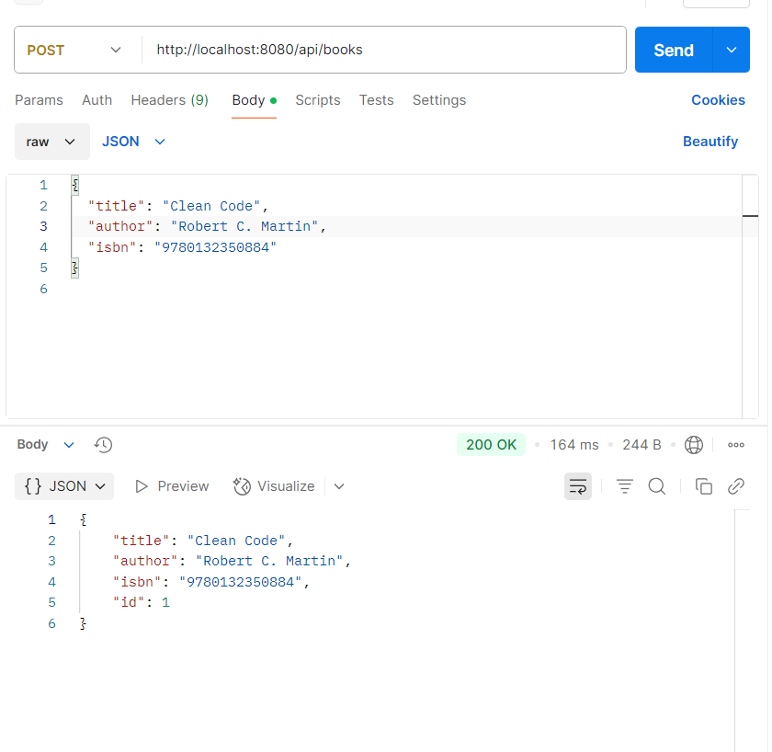

**Web Application**

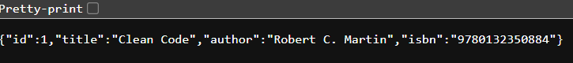

**Sending another rescord**



**Deleting a record**

